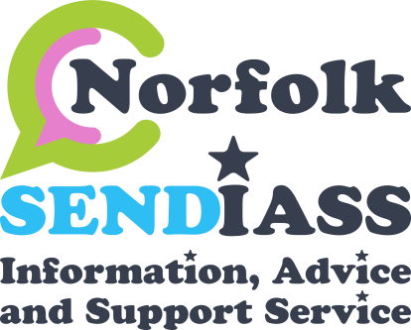
Special Educational Needs (SEN) Support Plan
Child’s Photo

 | Child’s Name |  | Things I like and enjoy …..
 | School
 | Year group/Form
 | You will know I’m finding things hard when …... |  | How I like to be supported…..
Parent  signature: |  | Young person/child  signature | SENCo  signature: | Review date:

LEGAL DOCUMENT
Norfolk SENDIASS Template for SEN Support

SEN Support Plan—Assess, Plan, Do, Review

Professionals involved |  | Main areas of Special Educational Need |  |  | High needs funding |  |  |  | Attainment Level
 |  |  | Cognition and Learning  Communication and Interaction Sensory and or Physical  Social, Emotional and Mental Health Medical |  |  | YES  NO |  |  | Previous Attainment:  Previous Progress:  Current Attainment: Expected Attainment: Current Progress:
Current Interventions/ Adjustments /Support  (all teachers need to be aware)  eg: differentiation/small groups/1:1/nurture) |  |  |  | How have needs been identified/assessed -  by school/outside professionals/parents |  |  |  | Any new information from parent/carers  E.g. change in family circumstances/ bereavement
Special Educational Needs | Specified and quantified Special Educational Provision |  |  |  |  | Short term out- comes | Has the target been achieved or what  progress has been made towards the target ? |  |  | Next steps: new targets or  alternative provision/ strategies?
1. |  |  |  |  |  |  | YES  No  Progress
2. |  |  |  |  |  |  | YES  No  Progress
3. |  |  |  |  |  |  | YES NO  Progress
4. |  |  |  |  |  |  | YES NO  Progress

THIS IS NOT A LEGAL DOCUMENT

