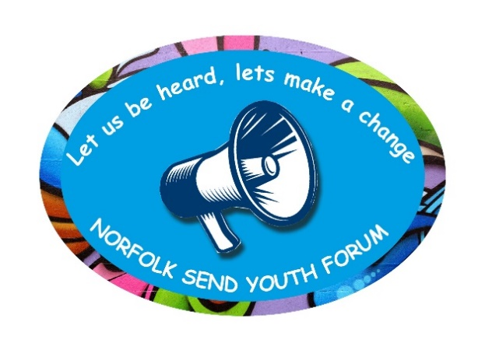

**Norfolk SEND Youth Forum**

**Wednesday 26th May 21 6:30 pm – 7:30pm**

**Meeting 6: Minutes (What has been discussed.)**

**Attendees:**

Charlotte

Lewis

Eve

Gabriel

Katrina

Tom (Norfolk Autism Partnership Board)

Dawn (Virtual School for SEND)

Belinda (Norfolk SEND Partnership – SENDIASS)

Bridget (Norfolk SEND Partnership – SENDIASS)

**Apologies:**

Noah

Bethan

Rachel

1. **Introductions/welcome new members/Ice Breaker Game (X1 truth/X1 lie).**
2. **Review minutes of last Meeting –** No changes to minutes
3. Tom from Norfolk Autism Partnership Board – Tom introduced himself, and explained that the NAPB works with people who make big decisions, and is seeking the views of people with LD and ASD; to get the decision makers to do what we need them to do.

Tom said he would ask X3 questions to get feedback from the group.

**Theme: Independence**

**Question 1.** What do you want to do by yourself (that you don’t want people to help you with)?

**Responses:**

* *“Learn how to travel on a bus”*

Discussion took place about the availability of buses in more rural areas, for example limited services, and how these do not fit with daily commute to Special school, and therefore have to rely on taxis, and opportunities to access independent travel training and opportunities to practice these skills.

* *“Job with the police”*
* *“Go to nightclubs”*
* *“Go out with someone to the pub”*
* *“Not to be scared to be independent”*
* *“Navigating a city and transport, makes me more nervous through no fault of my own”*
* *“Being independent gives people anxiety through no fault of their own; people tend to not admit stuff like that.”*
* *“ I want to do things on my own terms...which are enjoyable, for example go to the shop without relying on other people, being comfortable by myself.”*

**Theme: Relationships**

**Question 2 : Making friends/girlfriends & boyfriends, meeting people and feeling safe.**

* *“I have seizures…I need someone there .”*
* *“Gig buddy – someone to go with to gigs, someone of my own age/not mum and Dad” (on his terms, not the buddies)*

**Theme: The Future**

***Question 3: What do you want to do when you are older? (For example, job, life, what would make it better?)***

* *“A train driver – you need to be on the ball.”*
* *“Police”*

Information was shared by a member of the group - they recently attended a Neuro-diversity & Disability Open Evening with the Police – where learnt that there are lots of jobs within the police force, as the service wants to actively recruit people with disabilities, and advised on reasonable adjustments they can make.

<https://www.eventbrite.co.uk/e/make-your-difference-neurodiversity-disability-police-careers-event-tickets-131916494787>

* *“ My plan is to be an Anthropologist; to learn about people. I am going to study Sociology at University. I want to study society and explore new cultures. Write reports…provide consensus and advice…to address what needs to change…not just issues around disabilities, but also racial awareness, poverty….”*
* *“ I am housebound…I want to create things to make people happy…finding purpose and happiness…freedom and to access education.”*
* *“Normal people want us to fit their box.”*
* *“I want to be able to drive”*
* *“I want my blue badge back. They have taken it away…it’s not fair.”*

There was a discussion around the impact of when a blue badge is withdrawn, and often in conjunction with transition from receiving Disability Living Allowance (DLA), to Personal Independence Payments (PIP), once a young person reaches their 16th birthday, and the damaging impact of this.

Info:

<https://www.norfolk.gov.uk/care-support-and-health/support-for-living-independently/travel-and-transport/information-for-blue-badge-holders>

How to apply:

<https://www.norfolk.gov.uk/care-support-and-health/support-for-living-independently/travel-and-transport/blue-badges>

* *“From 0 – 15 I had a normal future planned, a partner, a job, a house, I was then diagnosed with ASD, nothing had actually changed but the label of disability changed everything. People judge you, and its about what you cannot do…”*

Tom acknowledged this as the “labelling effect” and said that can have all those things and achieve!!

**For Information:**

**The labelling effect - Definition:**

Labelling Theory explains how the identity and behaviour of people are influenced by how society has classified them.

Self – identity and behaviour of individuals may be determined or influenced by the terms used to describe or classify them. It is associated with the concepts of self-fulfilling prophecy and stereotyping.

<https://en.wikipedia.org/wiki/Labeling_theory>

1. **Pinboard Challenge**

Dawn reminded everyone about the Pin-board facility on the website and encouraged everyone to post a message. **Action:** Belinda to re-send everyone their password via email.

Here is the Link:

<https://www.norfolksendpartnershipiass.org.uk/young-people/norfolk-send-youth-forum-pinboard/login/>

1. **Any Other Business** (AOB): Eve explained that she is attending a national CYP Conference next week, supported by Dawn, and agreed she will feedback her experiences of it at the next meeting.
2. **Date & time of next meeting – 30th June 2021 @ 6.30pm – 7.30pm.**
3. **Feedback:**  Bridget invited group to do a thumbs up/middle/down to show how they were feeling at the end of the meeting – a unanimous thumbs up (everyone).

**Thank you to everyone for your participation and contributions!**

