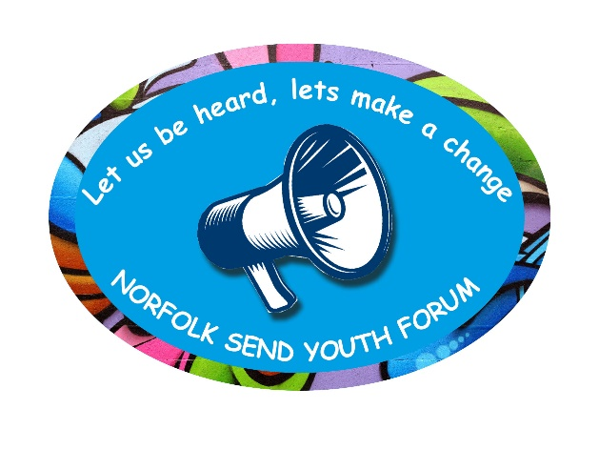

**SENDIASS Youth Forum**

**Wednesday 3rd March 2021 6:30 pm – 7:30pm**

**Meeting 4: Minutes**

**Attendees:**

Charlotte

Lewis

Eve

Bethan

Kizzy

Noa

Gabriel

Rachel (Norfolk Museums Service)

Dawn(Virtual School for SEND)

Belinda (Norfolk SEND Partnership – SENDIASS)

Bridget (Norfolk SEND Partnership – SENDIASS)

**Apologies:**

Jack

1. **Introductions/welcome new members.**

Kizzy and Noah were welcomed by the group.

1. **Review minutes of last Meeting –** No changes to minutes
2. **Update on Kick the Dust Project –** (Bethan)

**Bethan provided an update to the group.** Bethan has identified the Sunflower Lanyard as a possible item to be shown at the exhibition. Bethan explained that it is non gender specific, distinctive, and universally known as a way of signalling that a person has hidden disabilities.

**“*Wearing****the Hidden Disabilities****Sunflower****discreetly indicates to people around you including staff, colleagues and health professionals that you have a hidden disability and you****may****need additional support, help or more time.”*

**The Hidden Disabilities Sunflower is part of Hidden Disabilities Sunflower Scheme Limited, a private company based in the UK.**

The Hidden Disabilities Sunflower products are strictly not for resale by individuals, businesses or organisations - they are intended to be donated to your colleagues and customers free of charge.

* Bethan explained that these were originally used at airports and provided an example of when she was travelling home from a disability event wearing a badge that said “ASD”, when she discovered that her train had been cancelled. She explained that a member of staff saw her badge and they were pro-active in helping her.
* Eve shared a similar story of travelling independently, and the challenges of being visually impaired and how this makes it difficult to identify different signs/tickets/numbers and had to ask for help.
* Noa sought to share his experience in a Special school (unfortunately his internet kept interrupting and was invited to type this in the chat.)
* Dawn said that these are used in her sons’ mainstream school and have been very positive for those people who are exempt from wearing masks.
* Rachel explained that the recent type also has a hoop for hand sanitiser.
* Bridget reflected that this would be a historical artefact to reflect the context of COVID pandemic which we are currently living in.
* Tracey (supporting Lewis) said there are also armbands.
* Bethan added to this to inform the group that there are also pins available.
* Bethan explained that they are easily available on-line, as well as Tesco and Amazon.
* **Group agreed that this should be in the exhibition!**
* Bethan & Rachel also sought the groups favourites in dolls which have disabilities, **(Toy Like Me:** https://www.toylikeme.org/) which could also be shown in exhibition. Rachel advised to avoid items with lots of bits as trickier for curators to store/share and care for. Rachel shared the webpage and group narrowed down their favourites to: Hulk with stoma, Lego princess with Guide dog, and Anna, from Frozen, with Eye patch.

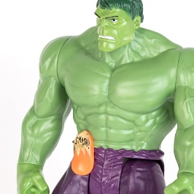 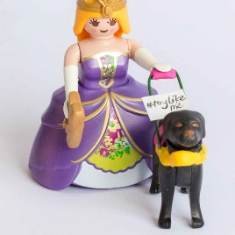 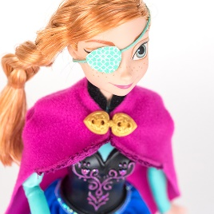

**ACTION:** Rachel and Bethan have asked if you could complete a feedback sheet providing reasons for these being your choice of toy, to be bought for the exhibition. It would be great if you could complete these and send them back by email (to Belinda).

1. **New development –** Bridget explained the development of an on-line message board for the SEND Forum. Discussion & feedback/queries were:
   * Can images/photos be uploaded onto the Message board?
   * Can there be a link to Live chat?
   * Speech icon? (I think you would like to be able to speak and this to be transcribed into text.)
   * Can we press a button to access an optional tutorial to provide step by step guide to using the pin-board?
   * Could it be possible to click on boxes and a voice can read to the user what is written?
   * Some of YF stated that they would still require help and support to use this as it is!
   * Dawn explained there is a team within the LA who can also look at stuff and check for any accessibility issues.

**ACTION:** Bridget to go back to designers with feedback

Gabriel joined the meeting for the first time and was welcomed by the group! We look forward to getting to know him!

1. **Professional Request to Consult with the group:**

Bridget explained that new procedure was agreed by the group at the last meeting and that we had received a request for the group to look at some booklets which are to be given to new Year 7s, to help with transition. Group have been asked to look at these and provide feedback. Group agreed to this.

**Action:** Bridget has now contacted Emma @Sewell Park. She has sent X2 versions of their transition booklet and some questions. Again, if you can have a look at these, please, and send in your thoughts, Bridget will collate your feedback and send to Emma. (Deadline is the end of the Easter Holidays).

1. **Date and time of next meeting is 14th April @ 6.30pm.**
2. **Feedback –** Please identify any positives/negatives about your experience of the Forum, and forward ideas and feedback via email.

**Thank you for all your valuable contributions!**

